WEST LONDON WASTE AUTHORITY
Report of the Treasurer and Managing Director | 4 December 2020
Budget Monitoring Report Period 7 (October)

SUMMARY
This report provides an update on financial and operational matters
RECOMMENDATION(S)
The Authority is asked to:-
- Note the current financial position, forecast for 2020/21
- Note the KPIs
- Note the financial decisions taken under the Scheme of Delegation to Officers
- Financial position – high level summary
A summary of the financial performance for the period and forecast to the end of the year is provided below:
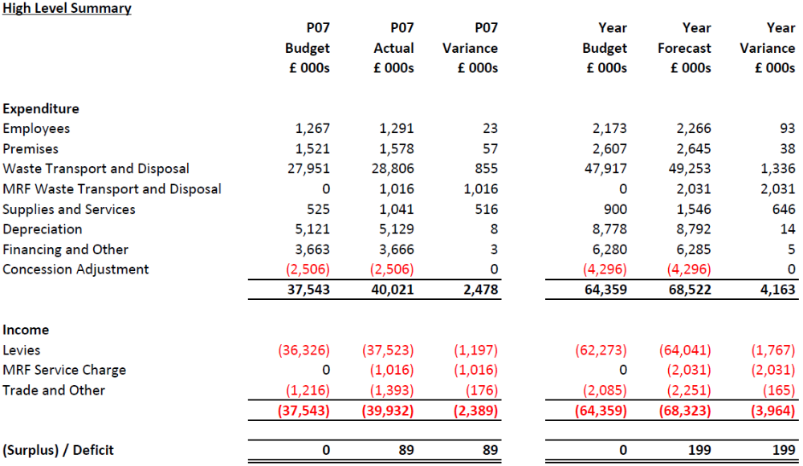
The summary shows how financial performance compares to the budget for both the period and the forecast for the year.
Whilst the overall deficit for both P7 and the year’s forecast are small, the impact of the Covid-19 pandemic remains the main feature of the performance so far this year. In particular its impact on waste flows (principally residual waste which accounts for the majority of spend) and therefore the large variances for Waste Transport and Disposal (WTD) costs and Levies.
The budget also includes the financial effects of a new dry mixed recycling (DMR) contract for Ealing. This is cost neutral for the Authority but creates off-setting variances in both MRF WTD costs and MRF Income.
These variances are detailed in the standard breakdown in Appendix 1 which separates out the main types of waste streams and distinguishes between PAYT and FCL activities. A summary of the key points follow.
Firstly in terms of PAYT waste, with more people working and studying from home and on furlough, there were increased volumes of household collected waste, particularly during June and July. For the period to P7 collected residual waste spending was £1.3 million more than budgeted reflecting increased waste volumes of 5%.
Similarly, food, mixed organic and green collections spending combined were £0.3 million more than budget reflecting the higher volumes of recyclable waste collected.
The increased volume and growth in costs of household collected waste is mirrored by an increase in the amount boroughs will have to pay through the PAYT levy and this totals £1.2 million for the period to P7. The PAYT charge is adjusted on a quarterly basis to reflect actual tonnages.
Secondly, in terms of FCL waste, the closure of HRRCs to the public in March resulted in significantly reduced overall waste volumes across all waste materials for the period. Following re-opening the picture for individual HRRC sites are varied with some seeing lower volumes and others higher.
Residual waste is the main component of HRRC waste costs and during the period this was £0.2 million or 5% lower than budgeted.
All of the above will be familiar patterns from the weekly services reports which have been shared with Members and borough Environment Directors since the start of the Covid-19 pandemic.
So, in terms of the year’s forecast of WTD costs, these have been built by focussing on the main waste streams (which account for the vast majority of the spend) and by separately considering the collections activity (PAYT) and HRRC activity (FCL).
For residual waste collections (PAYT) the forecast uses the current level of activity i.e. average for July to October where waste flows were a little more stable. This level has been projected to the end of the year.
The resulting forecast for residual waste collections gives by far the largest forecast variance of £1.9 million representing 5% higher residual waste volumes.
The increased waste collections have been reflected in the PAYT levy which is forecasting that boroughs in total will have to pay £1.8 million more than budgeted through the quarterly reconciliation exercises for the additional volumes of waste delivered.
For HRRCs (FCL), once again the main component is residual waste. Using volumes from July to October for forecasting the variance for the year is projected to be an underspend of £0.8 million.
Moving on to other key variances, there are two to note.
Firstly, the FCL now also includes the commencement of a dry mixed recycling (DMR) contract procured for LB Ealing as reported in Contract Updates to the Authority during the last year. This commenced in June and will be cost neutral for the Authority. The forecast spend from this service will be £2.0 million which will be offset by income from LB Ealing of £2.0 million.
Secondly, Supplies and Services includes £0.6 million for the Authority’s share of an increase in the SERC insurance premium. Under the PPP contract the risk of increases in the insurance premium is shared. The contractor is responsible for all the increase up to a threshold. The amount above the threshold is then shared with the Authority. It should be noted that the waste sector faces a very challenging insurance market and premiums are likely to rise in coming years.
- KPIs for 2020/21
The KPI table (Appendix 2) illustrates the performance across a wide range of key activities together with their RAG rating. Most indicators are on target however a number of activities have been effected by the Covid-19 pandemic and this is reflected in the RAG rating and commentary. These are briefly summarised below:
- KPI5 and KPI6 site closures to public, changes in operations and waste flows together with varied performance across HRRCs have all contributed to the lower overall levels of reuse, recycling and composted rates and percentage diversion from residual waste.
- KPI17, KPI18 and KPI21 reflect the hold on some face to face waste minimisation activities (e.g. events) as a result of the pandemic to ensure the safety of employees and residents. Events are a key driver of social media activity, so this has also been significantly reduced.
- Delegated decisions
To provide further transparency of operational arrangements, this standard section of the budget monitoring report summarises any significant financial decisions made by the Managing Director and/or Chief Officers under the Scheme of Delegations since those reported to the last Authority meeting.

There were none.

- Financial Implications – These are detailed in the report. Covid-19 is increasing costs due to increased waste.
- Impact on Joint Waste Management Strategy – Improvements to financial management in the Authority will continue to ensure that the Authority addresses policies of the JWMS.
Contact Officers | Jay Patel, Head of Finance 01895 54 55 10  jaypatel@westlondonwaste.gov.uk  Ian O’Donnell, Treasurer  ianodonnell@westlondonwaste.gov.uk  Emma Beal, Managing Director 01895 54 55 10  emmabeal@westlondonwaste.gov.uk

Appendix 1

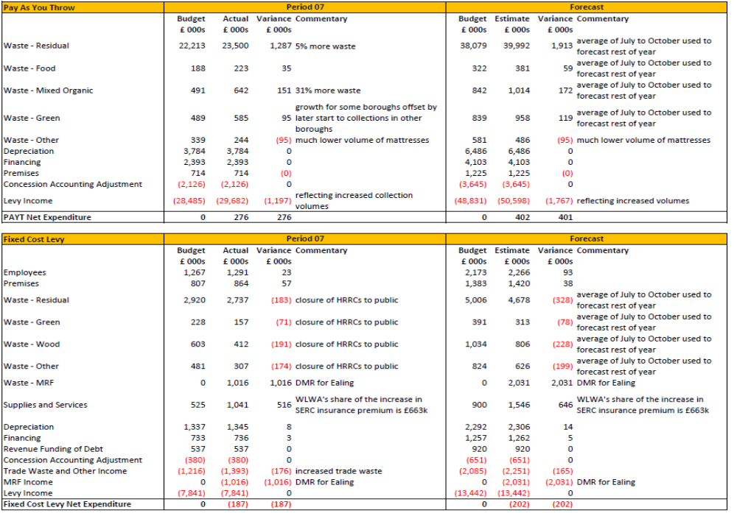

Appendix 2



